**Exercise 4: Functions**

**Scenario 1:** Calculate the age of customers for eligibility checks.

**Question:** Write a function CalculateAge that takes a customer's date of birth as input and returns their age in years.

set serveroutput on;

CREATE OR REPLACE FUNCTION CalculateAge(p_dob DATE) RETURN NUMBER IS

v_age NUMBER;

BEGIN

SELECT FLOOR(MONTHS_BETWEEN(SYSDATE, p_dob) / 12)

INTO v_age

FROM dual;

RETURN v_age;

END CalculateAge;

/

DECLARE

v_age NUMBER;

BEGIN

v_age := CalculateAge(TO_DATE('1985-05-15', 'YYYY-MM-DD'));

DBMS_OUTPUT.PUT_LINE('Age: ' || v_age);

END;

/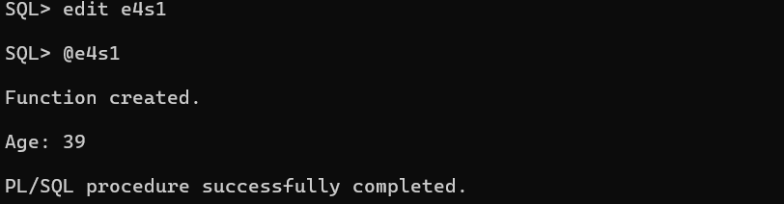

**Scenario 2:** The bank needs to compute the monthly installment for a loan.

**Question:** Write a function **CalculateMonthlyInstallment** that takes the loan amount, interest rate, and loan duration in years as input and returns the monthly installment amount.

set serveroutput on;

CREATE OR REPLACE FUNCTION CalculateMonthlyInstallment(p_loan_amount NUMBER, p_interest_rate NUMBER, p_duration_years NUMBER) RETURN NUMBER IS

v_monthly_rate NUMBER;

v_num_payments NUMBER;

v_monthly_installment NUMBER;

BEGIN

v_monthly_rate := p_interest_rate / 12 / 100;

v_num_payments := p_duration_years * 12;

v_monthly_installment := p_loan_amount * v_monthly_rate / (1 - POWER(1 + v_monthly_rate, -v_num_payments));

RETURN v_monthly_installment;

END CalculateMonthlyInstallment;

/

DECLARE

v_installment NUMBER;

BEGIN

v_installment := CalculateMonthlyInstallment(10000, 5, 10);

DBMS_OUTPUT.PUT_LINE('Monthly Installment: ' || v_installment);

END;

/

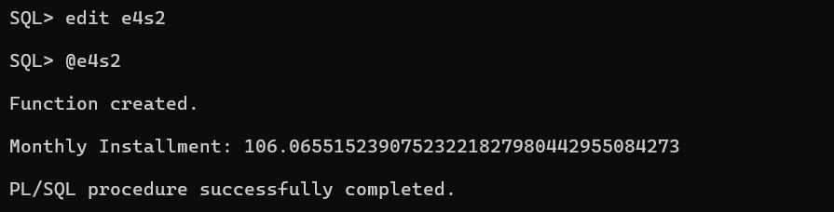

**Scenario 3:** Check if a customer has sufficient balance before making a transaction.

**Question:** Write a function **HasSufficientBalance** that takes an account ID and an amount as input and returns a boolean indicating whether the account has at least the specified amount.

set serveroutput on;

CREATE OR REPLACE FUNCTION HasSufficientBalance(p_account_id NUMBER, p_amount NUMBER) RETURN BOOLEAN IS

v_balance NUMBER;

BEGIN

SELECT Balance INTO v_balance FROM Accounts WHERE AccountID = p_account_id;

RETURN v_balance >= p_amount;

END HasSufficientBalance;

/

DECLARE

v_sufficient BOOLEAN;

BEGIN

v_sufficient := HasSufficientBalance(1, 1500);

IF v_sufficient THEN

DBMS_OUTPUT.PUT_LINE('Sufficient balance.');

ELSE

DBMS_OUTPUT.PUT_LINE('Insufficient balance.');

END IF;

END;

/

